Pathology Requesting Dashboard A+E Report: September 2016

- Overall Requesting Costs
£21217.59 Estimated spend on biochemistry/haematology/Immunology tests by HoEFT A+E for September 2016. (Includes Good Hope and Solihull)
Actual calculated costs from finance are £39,000 for all pathology tests including microbiology and histopathology, with a cost of £16,700 for biochemistry/haematology. This is significantly less than the £20184 that we predicted, but our figures still have value as a proportionate representation of cost.
This represents a 7% increase on August (£19794) but only a 0.3% increase on July (£21145).
During September we have records of 9033 distinct patients visiting Heartlands A+E (taken from MSS as arrival type MIN, MAJ, MWR and RES discarding AMU, SAU, PAU and AEC), compared to 8030 for August, so the change in cost is likely caused by an increase in patients.
The Bubble chart below displays the relative cost of each test, as you can see the most money is being spent on Troponin testing which accounts for 28.6% of total costs, but only represents 3% of total testing as it is significantly more expensive than other tests.
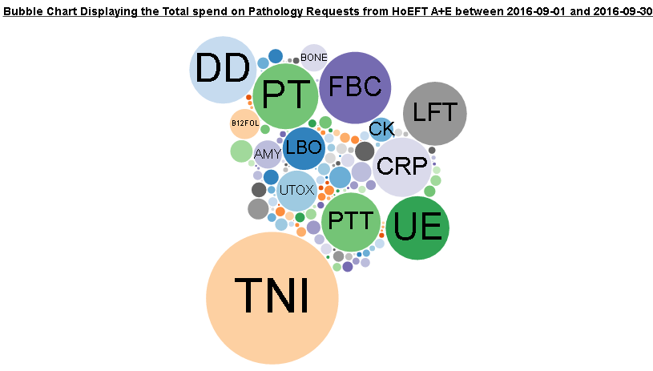
http://ebh24751:8000/graphs/costs_bubble/?start=2016-09-01&end=2016-09-30&view=spend
- Repeats
£92 was spend on A+E requests repeated within 180 minutes within A+E excluding troponin (£369 including) which is up from August’s £84 (£306 including Troponin).
Including requests duplicated on A+E patients by outside requestors (probably from the discharge location) £158 was spent on tests duplicated within 180 minutes in September excluding Troponin (£598 including) compared to the£152 spent in August (£522 Including Troponin).

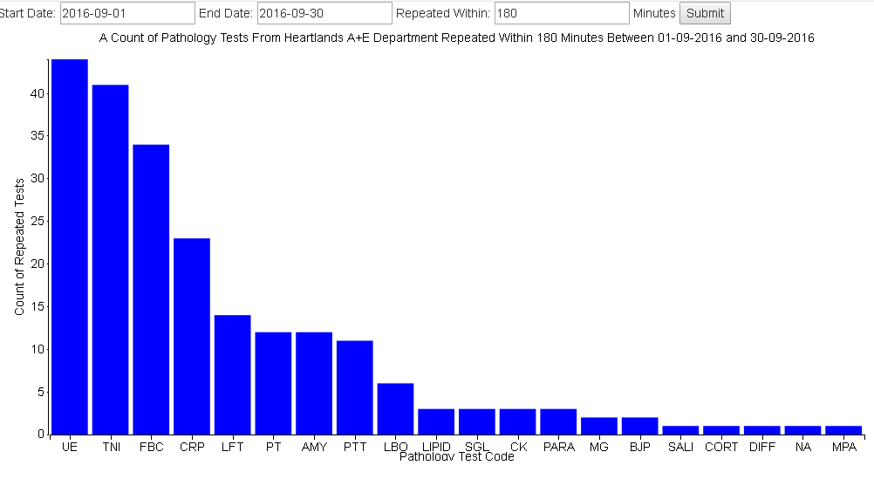
http://ebh24751:8000/graphs/repeats/?start=2016-09-01&end=2016-09-30&mins=180
- Add-on tests
£702 extra was charged to A+E in September for tests added on more than 4 hours after the initial test. This is less than the £747 extra added in August.
This is not an exact representation of the additional cost being place on A+E by add-on test as 4 hour difference is only an estimate of the time taken to leave A+E. When reduced to a 1 hour window the cost rises to £1362 but is likely to contain some tests being added from within the department.
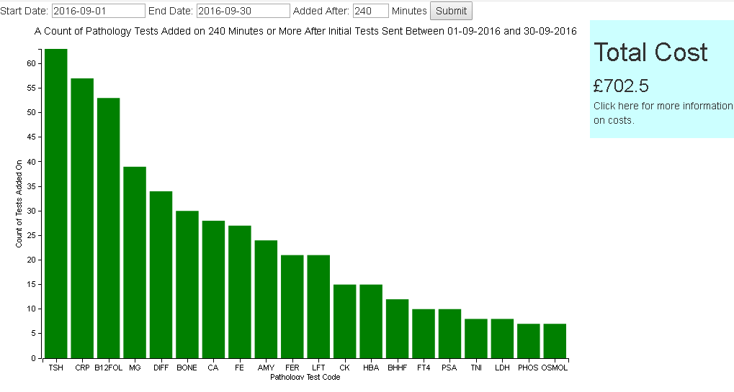
http://ebh24751:8000/graphs/addons/?start=2016-09-01&end=2016-09-30&mins=240
Investigating this in further detail we can see that the biggest cost comes from B12 and Folate addons.
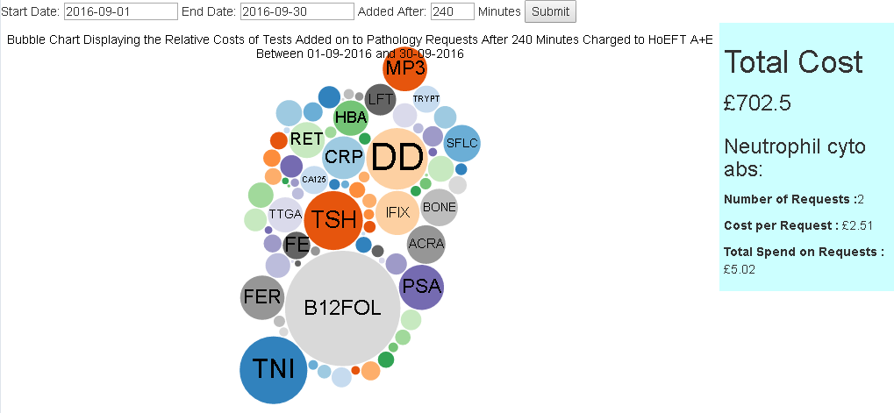
http://ebh24751:8000/graphs/addons/cost/?start=2016-09-01&end=2016-09-30&mins=240
- ICE Requesting
63% of A+E pathology requests made during September 2016 were made electronically through ICE requesting a slight decrease from the 64% seen in August.
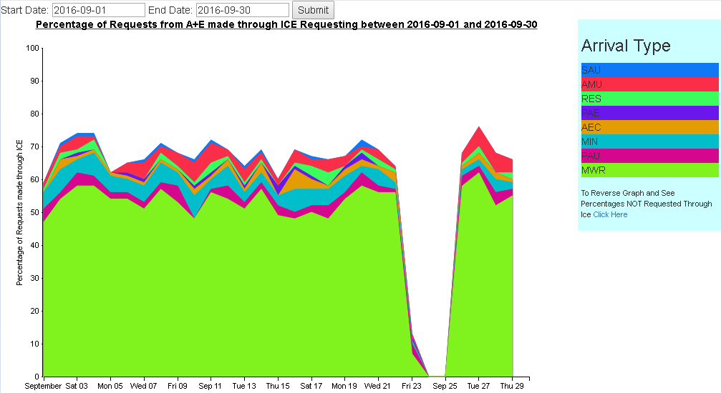
http://ebh24751:8000/graphs/ice/?start=2016-09-01&end=2016-09-30
The sudden drop in requesting seen from the 23rd to the 25th was caused by network problems within the A+E department.
- Requesting Levels
We hope that displaying relative requesting levels for each clinician with a breakdown of caseload we might be able to discover some erroneous requesting.
As a hypothetical example if a clinician were requesting a lot of Troponin tests patients with a genitourinary system diagnosis and other clinicians weren’t that might indicate a misunderstanding of the correct use of tests.
This data section is less clearly presentable than others at it will require some clinical interpretation that the project team is unable to provide, but we hope that we can encourage others to find such discrepancies.
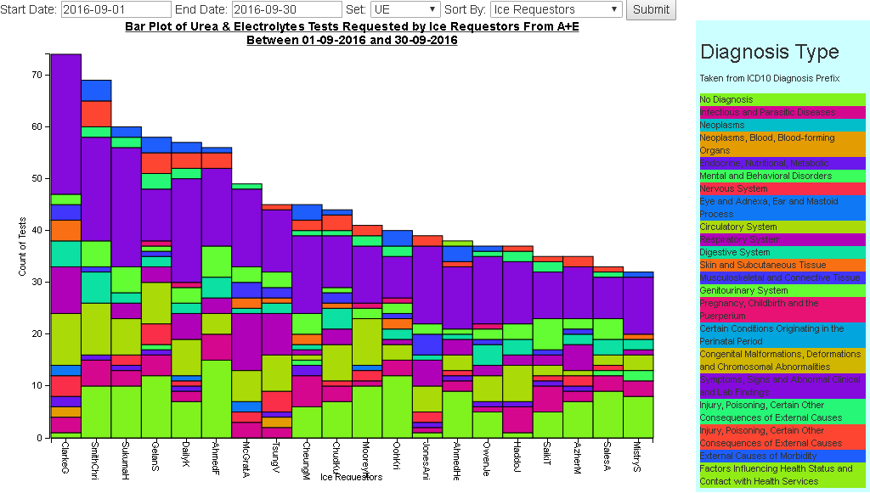
http://ebh24751:8000/graphs/compare/?start=2016-09-01&end=2016-09-30&set=UE&splitby=Ice
Feedback Response
Will include responses to feedback from meetings here in future reports
Changes to the Dashboard
Added a cost calculator to the Add-ons graph and created a cost bubble chart for it
Changed outliers to display patient ID instead of specimen number
Changed default load times on add-ons and repeats
Future plans
Develop some targets for change
Create costs bubble chart for repeats
Create display of costs over time
Develop front page of website
Bugs
The time flow graph displaying sample time in transport, in lab or waiting to be viewed is inaccurate from 25th September onwards. The ICE server that I need to get the date viewed from has got the wrong memory installed and so can only access a reduced portion of it. Because of this non-essential operations such as my query have been deprioritised. The situation is being investigated but I don’t expect to be able to get a reliable data feed for this anytime soon.
Some tests on the requesting levels graph will display errors when viewed by ice requestor. This is due to it trying to draw the graph with no values as all of them were not ice requested.
Contact Details
This report was created by Pip Croxford as part of an MSc in Health Informatics for the University of Manchester. She will happily answer any questions and would be grateful for feedback.
Email: pip.croxford@heartofengland.nhs.uk
Ext: 52956

